**PRACTICAL NO. 2**

**Desing a web page that makes use of :**

1. **Table tag:**

**Code:**

<!DOCTYPE html>

<html lang="en">

    <head>

        <title>Student table</title>

    </head>

    <body>

        <table border="2" align="center" style="color:black; background-color: whitesmoke; border-color: black; text-align: center; width:100%;">

            <tr>

                <th colspan="4">Student table</th> *<!--using colspan -->*

            </tr>

            <tr>

                <th>Sr. no.</th>

                <th>Roll no.</th>

                <th>Name</th>

                <th>Marks</th>

            </tr>

            <tr>

                <td>1</td>

                <td>123</td>

                <td>Jayesh</td>

                <td>100%</td>

            </tr>

            <tr>

                <td>2</td>

                <td>124</td>

                <td>Aryan</td>

                <td>101%</td>

            </tr><tr>

                <td>3</td>

                <td>125</td>

                <td>Sandesh</td>

                <td rowspan="2">99%</td>  *<!--using rowspan attribut-->*

            </tr>

            <tr>

                <td>4</td>

                <td>126</td>

                <td>Ashutosh</td>

*<!-- <td>100%</td> -->*

            </tr>

        </table>

    </body>

</html>

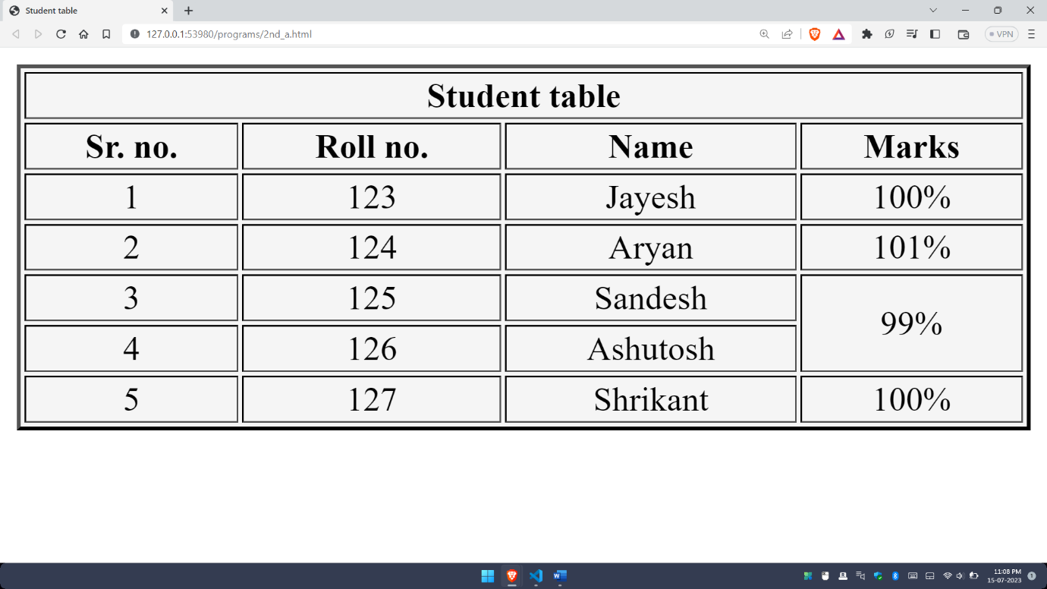**Output:**

1. **Form tag:**

**Code:**

<!DOCTYPE html>

<html lang="en">

<head>

    <title>Login form</title>

</head>

<body>

    <form action="longin from.db">

        <div>First name: <input type="text" value="Enter name" id="fn"></div>

        <div>Last name: <input type="text" value="Enter last name" id="ln"></div>

        <div>Contact no.: <input type="number" id="cn"></div>

        <div>Gender:

            <input type="radio" id="g1" name="gen">Male

            <input type="radio" id="g2" name="gen">Female

        </div>

        <div>Hobbies:

            <input type="checkbox" id="h1">Playing

            <input type="checkbox" id="h1">Dancing

            <input type="checkbox" id="h1">Singing

            <input type="checkbox" id="h1">Swimming

        </div>

        <div>Country:

            <select name="con" id="cntry">

                <option value="1">India</option>

                <option value="2">China</option>

                <option value="3">America</option>

                <option value="4">Egypt</option>

                <option value="5">Canada</option>

                <option value="6">Combodia</option>

                <option value="7">Russia</option>

            </select>

        </div>

        <div>

            <input type="reset" value="Clear data">

            <input type="submit" value="Login">

        </div>

    </form>

</body>

</html>

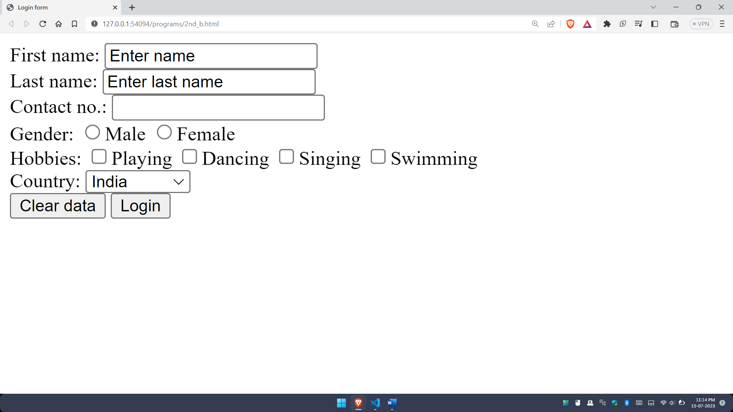**Output:**

1. **Navigation across multiple pages:**

**Code:**

<!DOCTYPE html>

<html lang="en">

<head>

    <title>Page navigation</title>

</head>

<body>

    <h3>Examples of page navigation</h3>

    <a href="https://www.google.co.in/">Click here to visit google</a><br>

    <a href="https://www.amazon.in/">Click here to visit amazon</a>

</body>

</html>

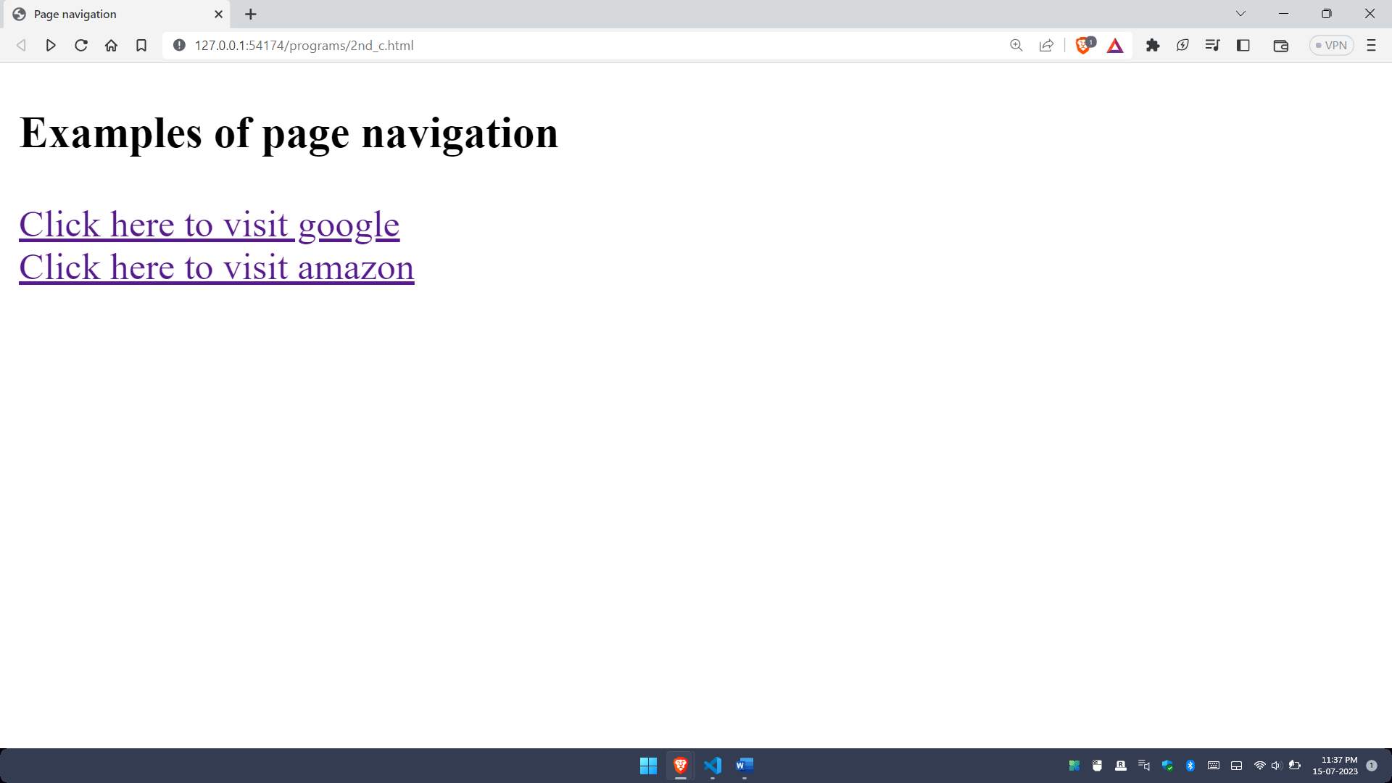**Output:**

1. **Embedded multi-media elements**

**Code:**

<!DOCTYPE html>

<html lang="en">

<head>

    <title>Audio</title>

</head>

<body>

    <audio controls autoplay>

        <source src="https://commondatastorage.googleapis.com/codeskulptor-demos/DDR_assets/Sevish_-__nbsp_.mp3" type="audio/mp3">

    </audio>

</body>

</html>

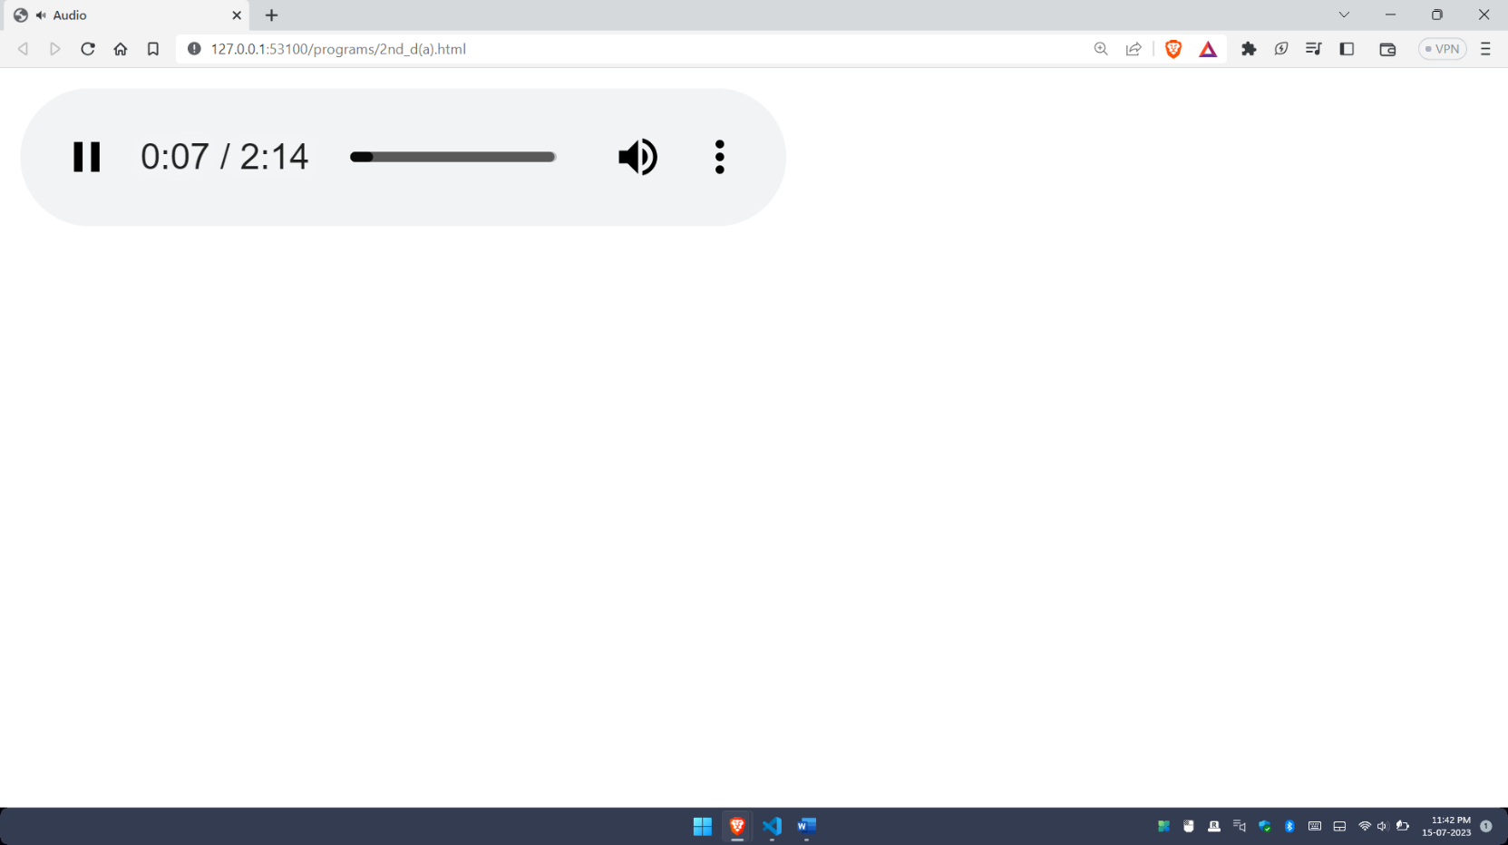**Output:**

**Code:**

<!DOCTYPE html>

<html lang="en">

<head>

    <title>Document</title>

</head>

<body>

    <video controls autoplay style="width: 400px;">

        <source src="sea.mp4" type="video/ogg">

    </video>

</body>

</html>

**Output:**

